Employee Instruction Email
Hi [name],

We're so excited to be partnering with [company name] to offer you instant access to over 5,000 workspaces around the world.

Within the next few minutes, you will receive your invitation email to set up your Upflex account. Here’s what to expect.
- When you receive your invitation email, click the link and set up a strong password. If the password is not strong enough, the button will not let you click it.
- Once you set up your password, download the app: (iOS and Android). You can start to make workspace reservations right away!
- Make sure to turn on Location Services. The Upflex app can’t work unless it knows your location. When you first open the app you will be prompted to allow Location Services. You can also turn this on from your phone Settings.
- On the app, if you can’t find workspaces in the location you need, you can request one from us and our Space Acquisition Team will work to find one for you! The Request a Space button shows up when there are no search results on the app, or at the bottom of the list view.
- If you run into any issues while at a workspace, use the app to contact Upflex support. You can find Support in the Profile menu. You can also email support@upflex.com.
If you have any questions, please don’t hesitate to contact us! We have a FAQ at help.upflex.com and can answer your questions via email (support@upflex.com) or on the Chatbot on our website.

Employee Activation Email
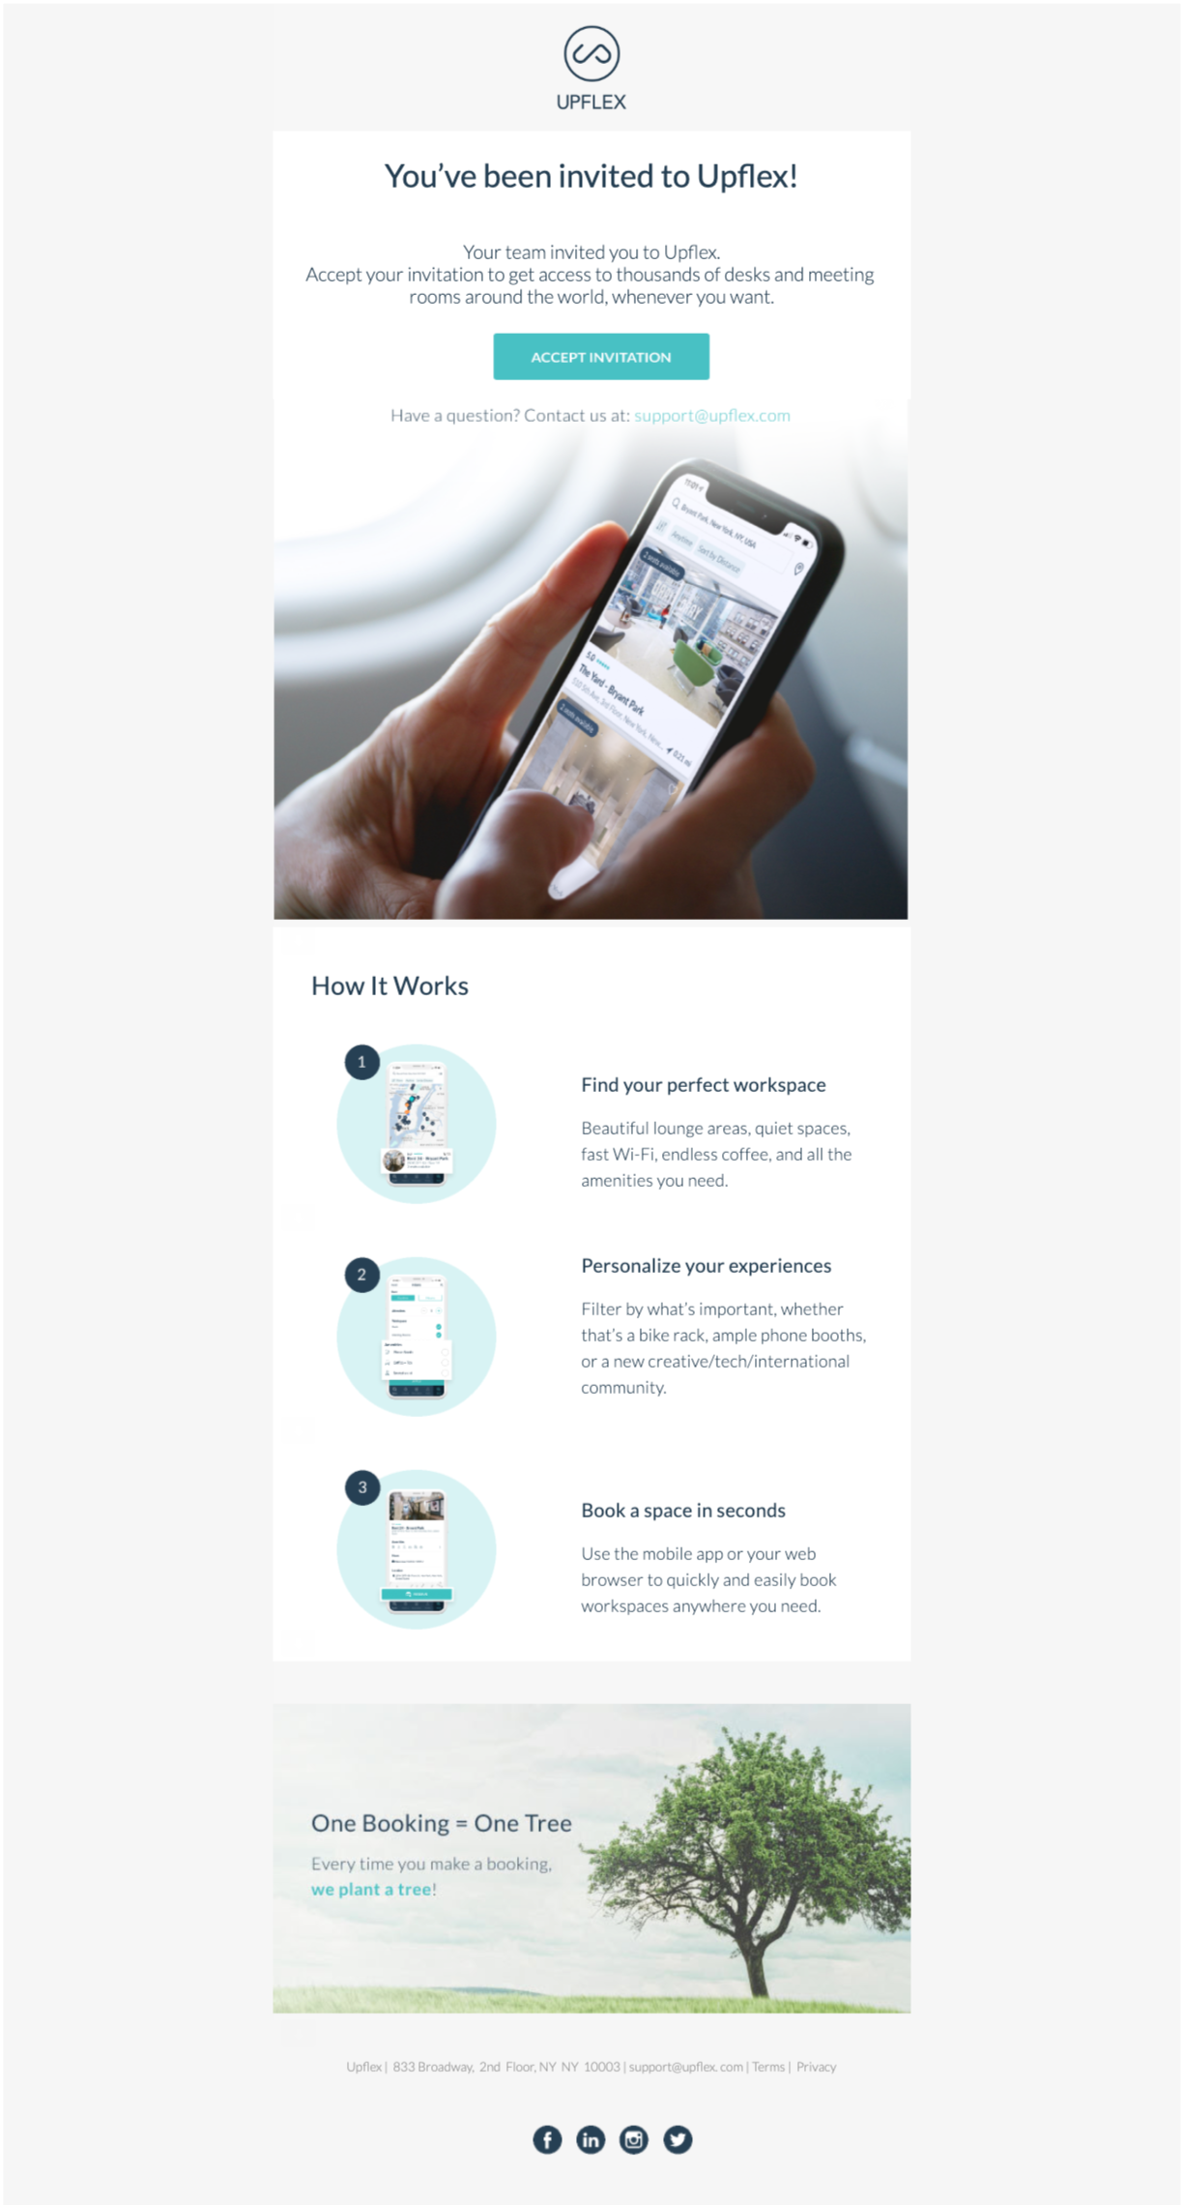

Employee Onboarding Emails

Email 1

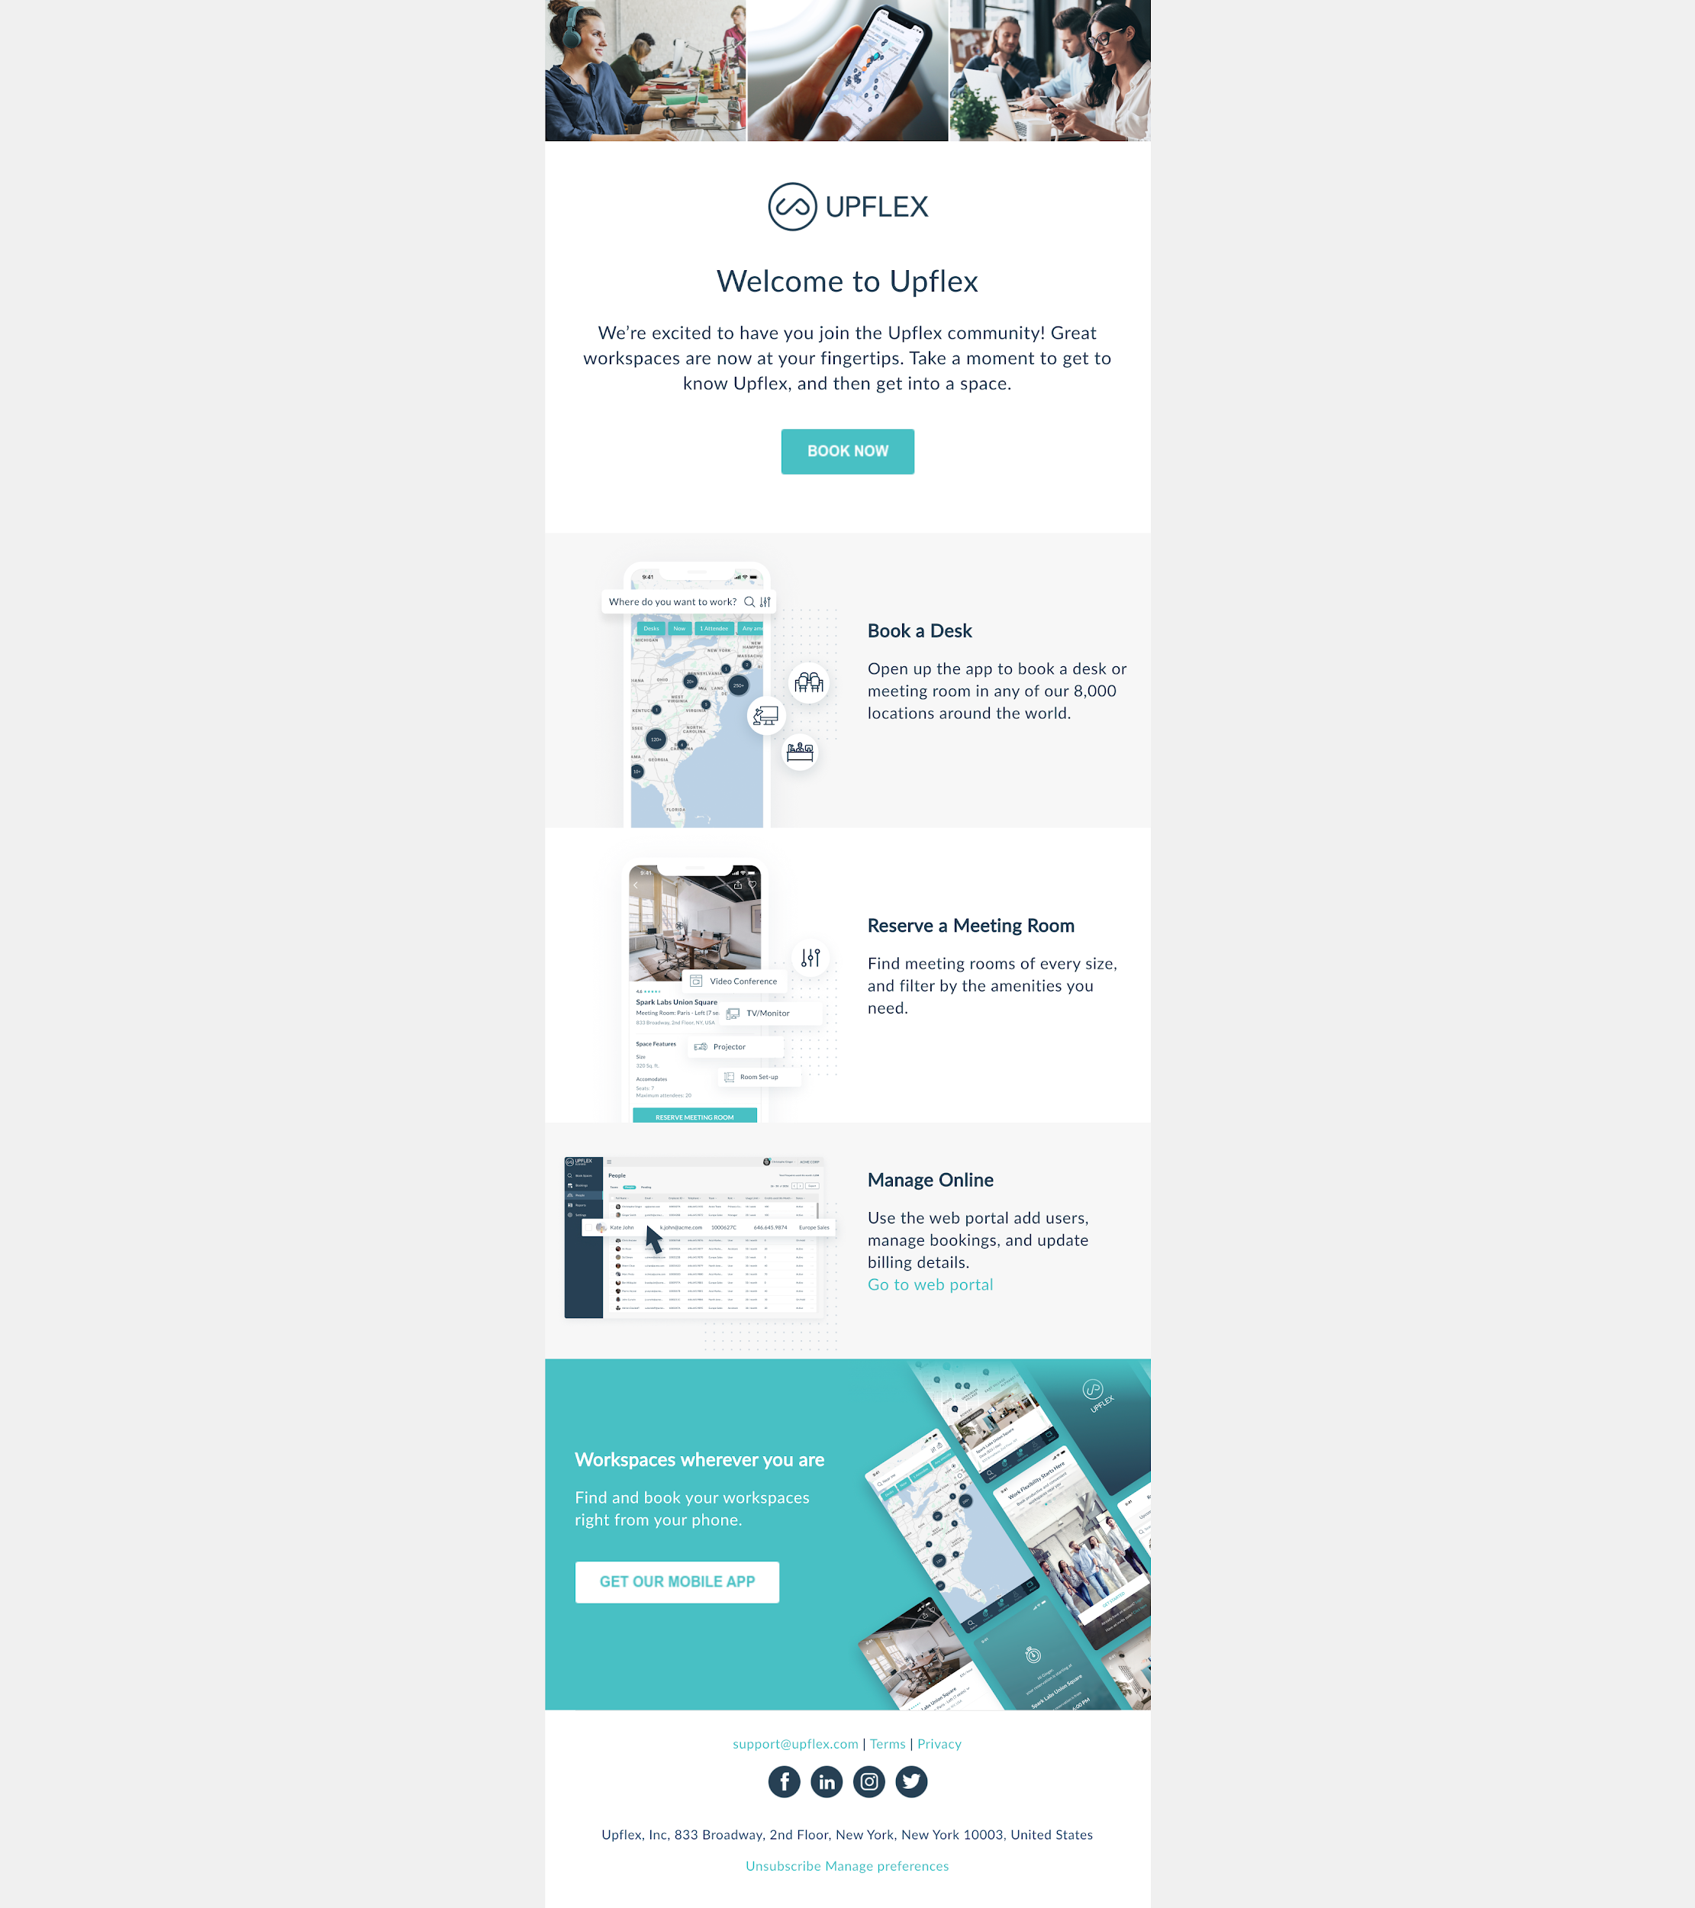

Email 1 Copy:

Welcome to Upflex
We’re excited to have you join the Upflex community! Great workspaces are now at your fingertips. Take a moment to get to know Upflex, and then get into a space.
Book a Desk
Open up the app to book a desk or meeting room in any of our 8,000 locations around the world.

Reserve a Meeting Room
Find meeting rooms of every size, and filter by the amenities you need.

Manage Online
Use the web portal add users, manage bookings, and update billing details.
Go to web portal

Email 2

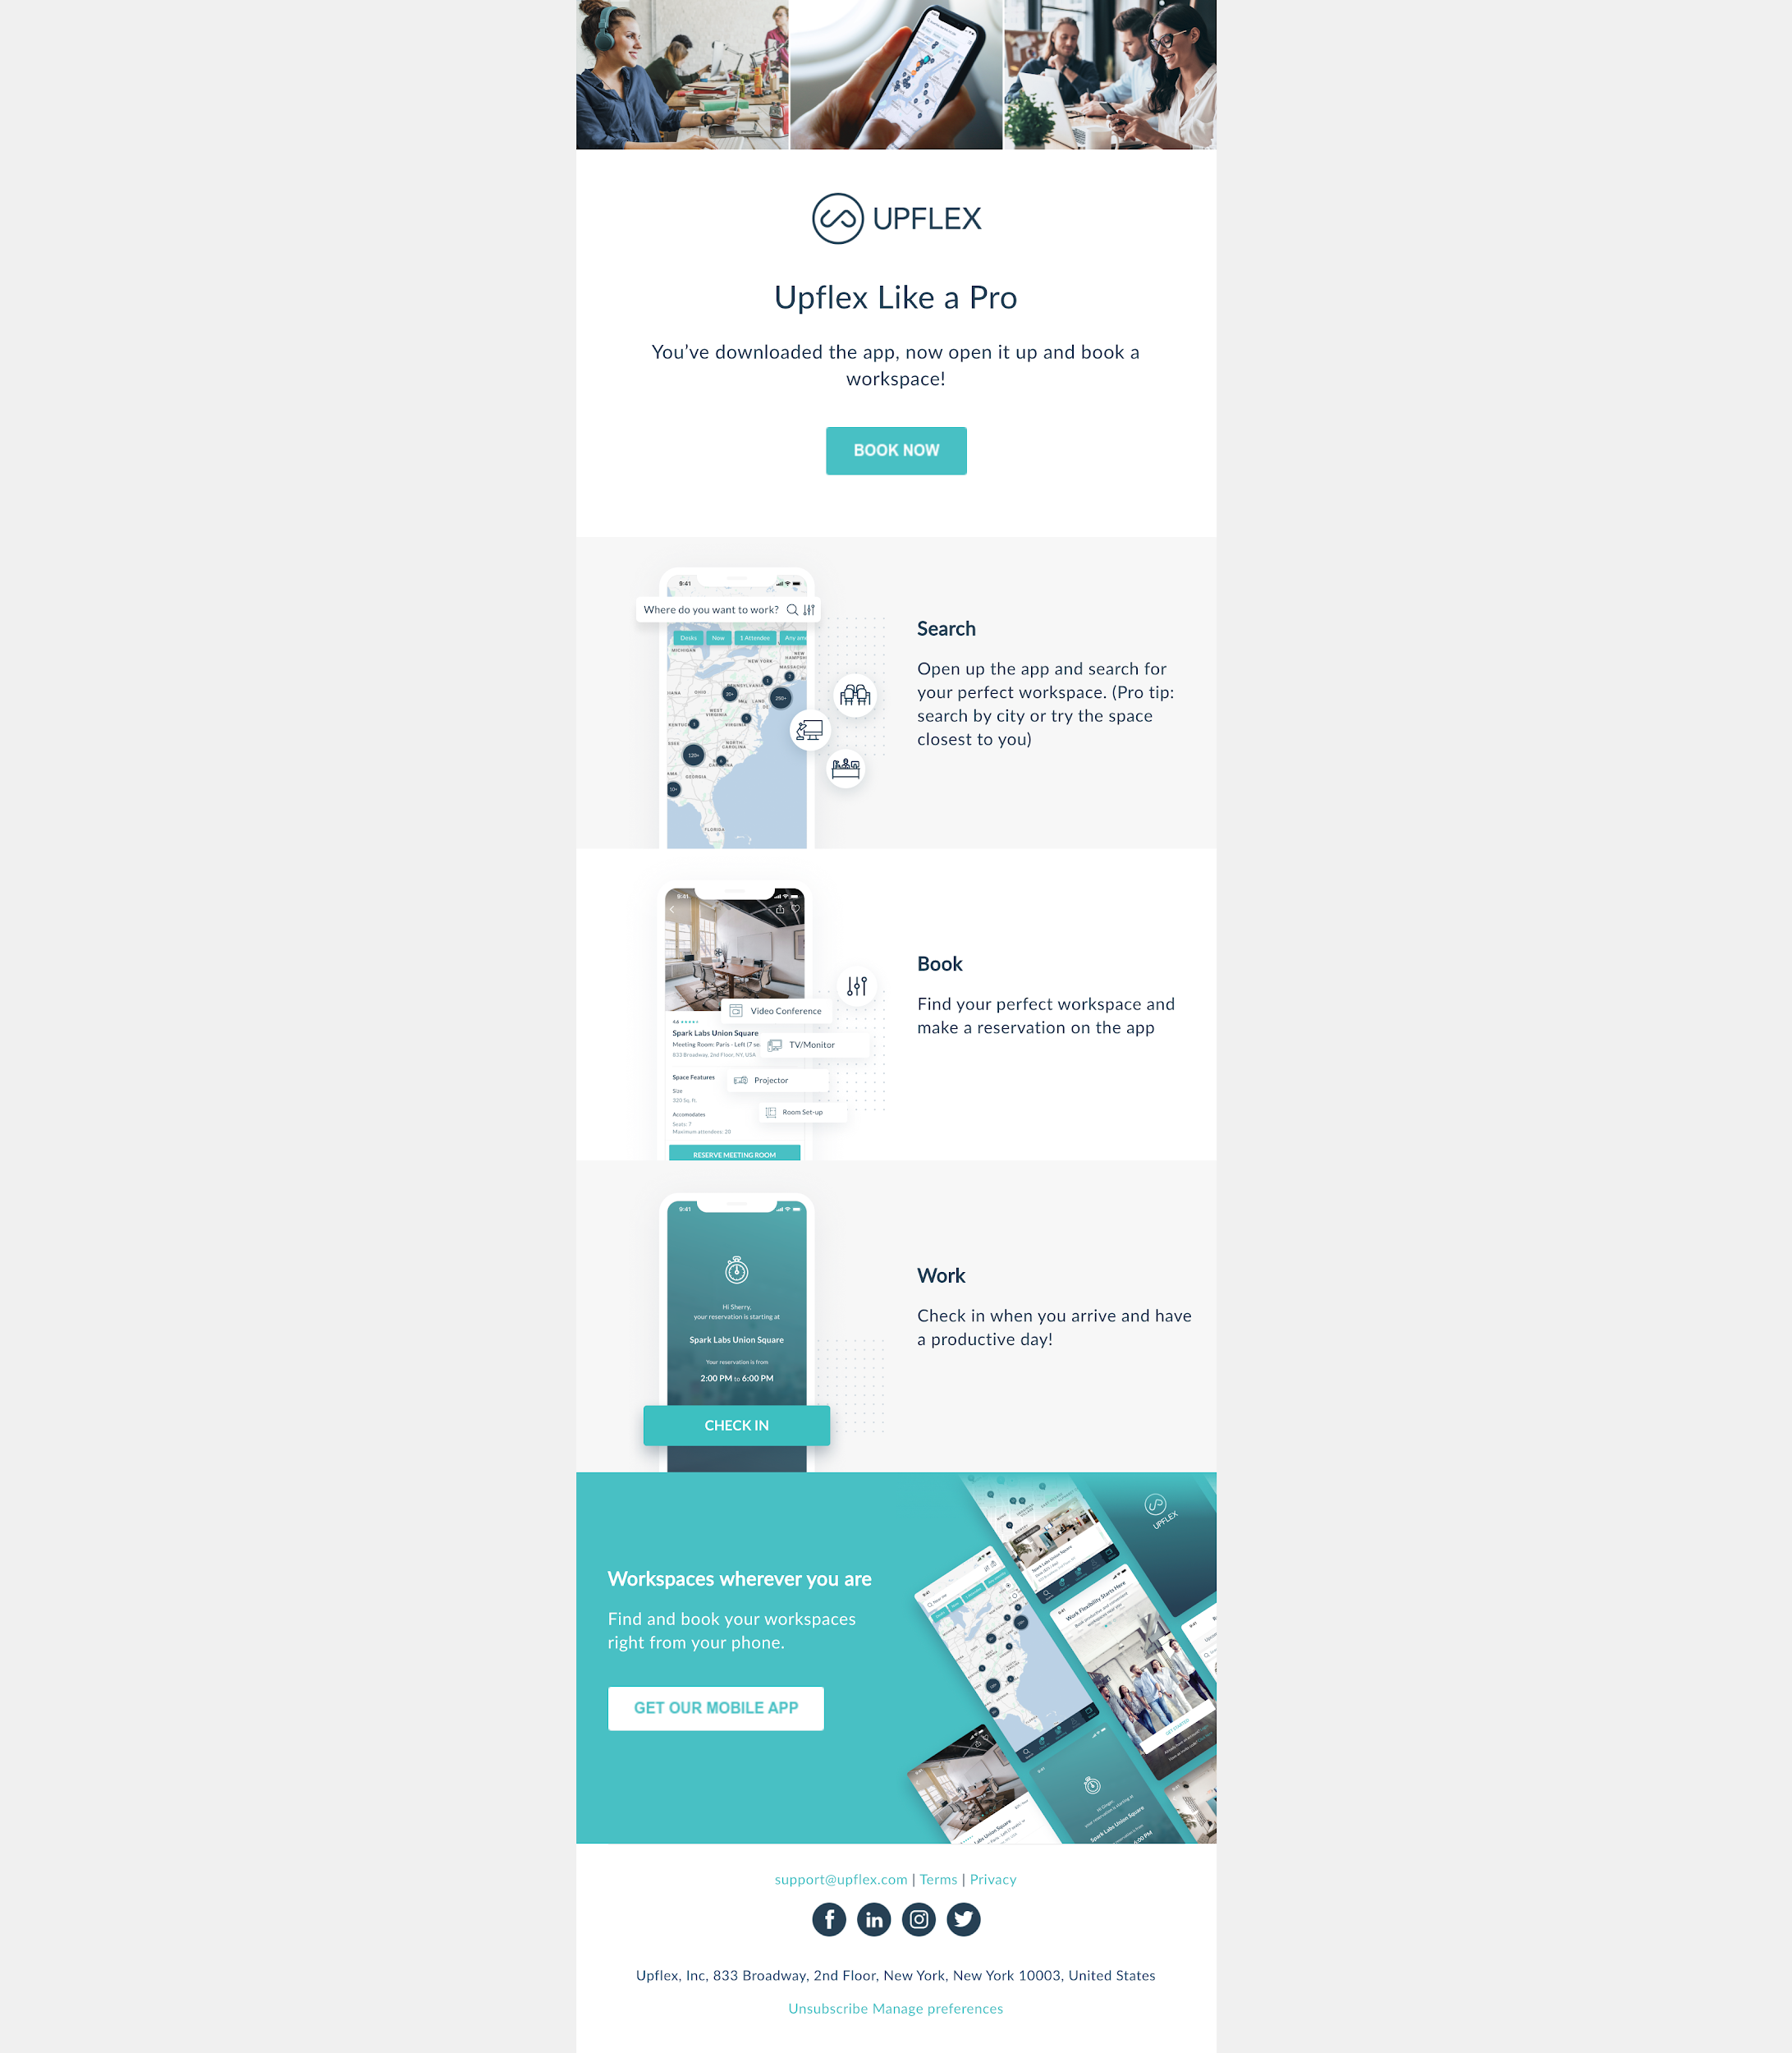

Email 2 Copy:

Upflex Like a Pro
You’ve downloaded the app, now open it up and book a workspace!

Search
Open up the app and search for your perfect workspace. (Pro tip: search by city or try the space closest to you)

Book
Find your perfect workspace and make a reservation on the app

Work
Check in when you arrive and have a productive day!

Email 3

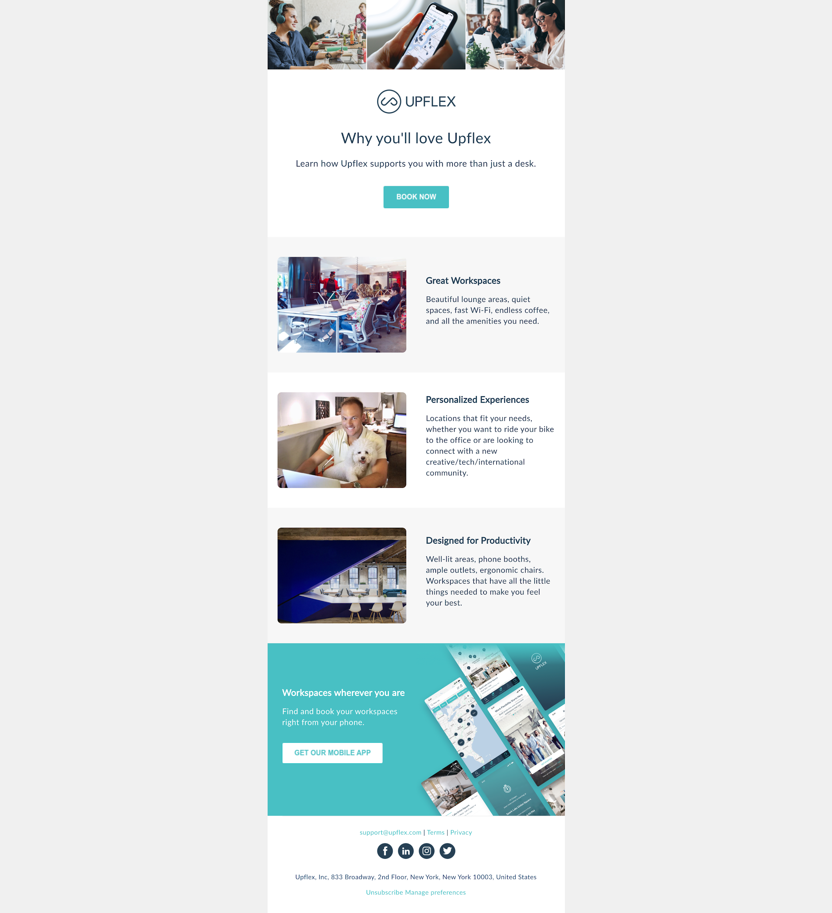

Email 3 Copy

Tips & Tricks
Try these tips and tricks to get the most out of Upflex!

Search by amenities
Need a meeting room with a whiteboard? Projector? You can search by amenities to find the perfect spot.

Fav a space
Save your favorite spaces to easily find them again. Try faving the space near home so you have a place to work when you don’t want to commute.

Book out of town
Search by city to find spaces when you’re traveling for work (or when you’re visiting family and need to escape and get some work done)

Add to calendar
Easily remember your bookings by adding them to the calendar immediately after you make a reservation

Invite a colleague
Add your team members on the business portal so you can both use Upflex — perfect for off-sites!

Email 4

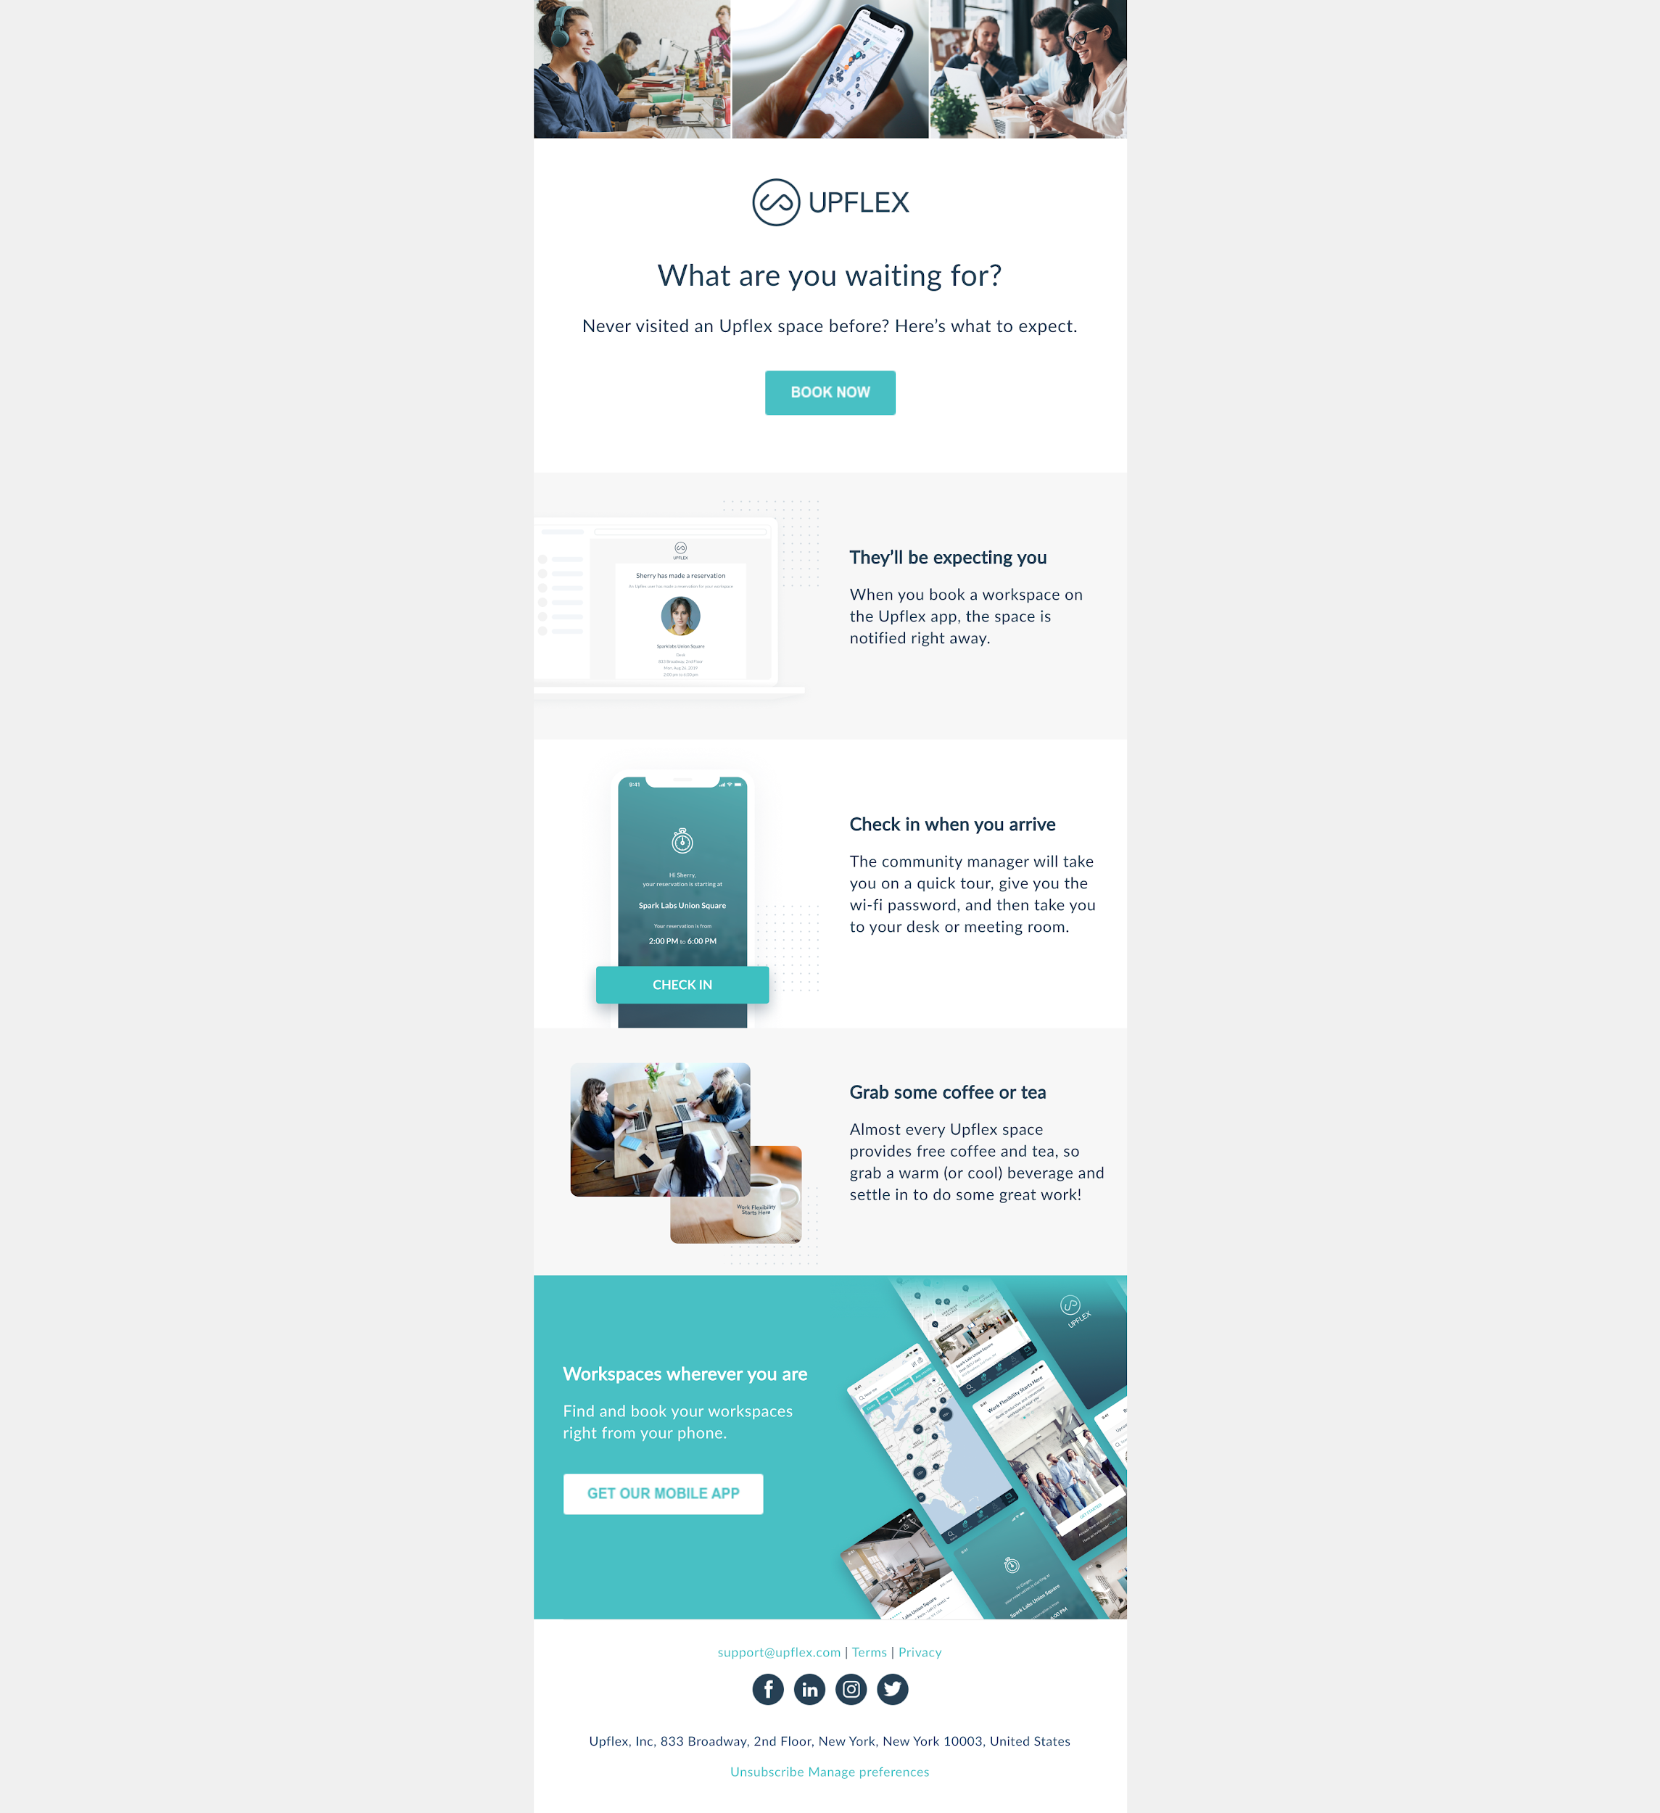

Email 4 Copy

Why you'll love Upflex
Learn how Upflex supports you with more than just a desk.

Great Workspaces
Beautiful lounge areas, quiet spaces, fast Wi-Fi, endless coffee, and all the amenities you need.

Personalized Experiences
Locations that fit your needs, whether you want to ride your bike to the office or are looking to connect with a new creative/tech/international community.

Designed for Productivity
Well-lit areas, phone booths, ample outlets, ergonomic chairs. Workspaces that have all the little things needed to make you feel your best.

Email 5

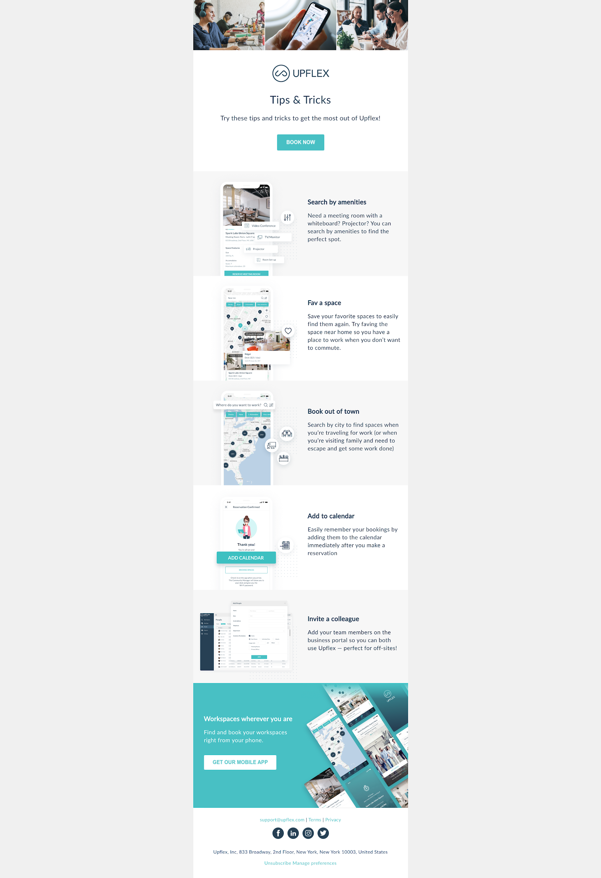

Email 5 Copy

What are you waiting for?
Never visited Upflex space before? Here’s what to expect.

They’ll be expecting you
When you book a workspace on the Upflex app, the space is notified right away.

Check in when you arrive
The community manager will take you on a quick tour, give you the wi-fi password, and then take you to your desk or meeting room.

Grab some coffee or tea
Almost every Upflex space provides free coffee and tea, so grab a warm (or cool) beverage and settle in to do some great work!

