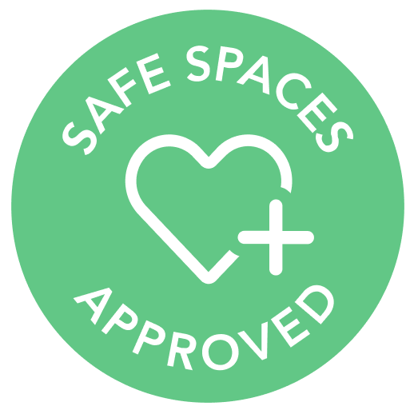
In this workspace we are practicing the following health & safety practices to keep you safe:
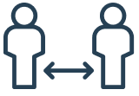 | 1. Social distancing  We keep members 6 feet away from each other and prevent unnecessary close contact to help prevent the spread of infection.
2. Cleaning & disinfecting
We clean and disinfect all surfaces at least twice a day, especially high-touch surfaces.
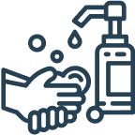 | 3. Personal hygiene  We provide hand sanitizer and disinfectant wipes, and will educate on proper hand-washing.
4. Food & beverage
We offer only paper cups for beverages and pre-wrapped food items, if any.
5. Engineering controls
We reduce exposure to hazards without relying on personal behavior, such as by using HEPA air filters and physical barriers.

