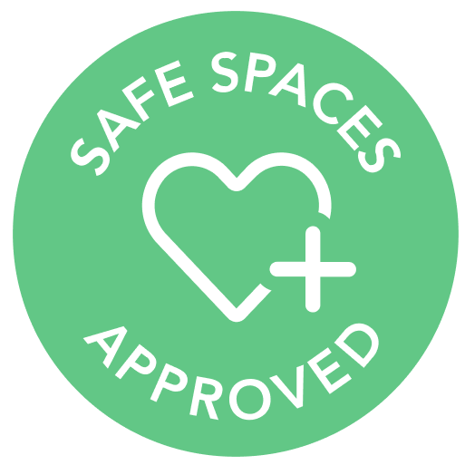
Reopening Safety Basics & Risk Assessment from Safe Spaces™

As countries around the world are cautiously reopening following the COVID-19 pandemic, operators and owners of shared spaces need to be able to make the most educated decisions on how they will proceed.

The following infection prevention and assessment tool, developed with infectious specialist Karen K. Hoffmann, should be used to help space operators consider the various risks as they make their decisions on how to welcome people to their spaces.

We focus on the following common decision points you may be facing.

The risks of COVID-19 entering your facility:

- Access Points
Limiting access points to your space can help reduce the risk of COVID-19 entering your facility. If you have multiple entrances, are you able to close off all but one and ensure there is a staff member at the open entrance at all times? Support social distancing if multiple people arrive at the same time with floor markings to maintain 6 feet separation.
- Guests
While the only way to keep COVID-19 out of your space completely is to not allow anyone inside, you can evaluate if and how you want to restrict access to your space.
  - Some workspaces are restricting their space to members only. Consider if your membership base is large enough for this strategy to work for you.
  - You may want to allow only guests into the space who are using a full day pass or full-day room rental, to cut down on the number of people coming into and out of your space in one day.
  - If your members frequently bring guests into the office for short meetings, you may want to consider limiting access to these guests or requesting these meetings be virtual as much as possible.
  - A good strategy in all situations is to be sure to register every person who enters your space so you have their contact information for contact tracing purposes or to notify them if you later discover they may have been exposed.
- Fever & respiratory screening
Guidelines and requirements for screening people who enter your workspace may vary through the world. Depending on where you are located you may be required to do this, or it may be considered not recommended.
  - Screening can have different meanings. You may consider having all visitors verbally confirm they do not have a fever or respiratory symptoms before entering your space.
  - You may want to take the temperature of every staff member at the beginning of their shift and send them home if ill.
- Events
Large gatherings are considered high risk, so evaluate if you want to host events at all and if so, how you will control the number of attendees. Be sure to abide by local regulations for events, if you choose to have them.
- Staff
If you have staff working at multiple locations, consider dedicating them to one location only.

Prevent spread of COVID-19:

- Signage
There are many signage options available to inform and remind clients and staff about your policies for safe spaces including hand hygiene, social distancing and respiratory hygiene and cough etiquette.
  - Consider placing signage at the entrance and near other key locations (e.g. restrooms, dining areas, conference rooms).
- Social Distancing
Consider strategies for enforcing social distancing. Make these guidelines clear upon entry into your space in order to help enforce them.
  - You may want to discourage people from lingering in lounge and common areas
  - Remove chairs or tape off sections of sofas in order to enforce social distancing.
- Dining Areas
Communal dining areas can be a potential risk area. Consider if you want to close off your communal dining area or if you want to implement additional precautions.
  - You may be able to keep dining areas open but encourage people to eat at their desks and not to linger.
  - If you are able, consider implementing a dining area schedule to prevent too many people from using the space at one time.
  - If your workspace offers communal food or drink, consider how to make this area more low-contact.
  - Schedule additional sanitizing for the dining area.
- Restrooms
Restrooms and lines to use the restrooms are often high-traffic. Consider marking tape on the floor in 6 feet spaces for restroom lines. Studies also show that flushing toilets can release droplets into the air, so hang signs to remind people to close the lid of the toilet before flushing. If necessary, install toilet lids.
- Facemasks
Facemask usage is an important part of preventing the spread of COVID-19. Consider how you want to require facemask usage in the workspace.
  - Consider if staff members at the front desk are required to wear facemasks.
  - You may want to implement universal facemask use by all people in common spaces but allow people in private offices to remove masks if they want to.
  - You may require people to remove masks at their desks but wear them if they move from their desk.
  - You may require them in lounge areas, but not elsewhere.
- Hand Hygiene
In addition to using facemasks, hand hygiene can reduce risk of exposure by not self-inoculating from touching contaminated surfaces.
  - Encourage frequent hand-washing.
  - Consider offering alcohol-based hand rub (at least 60% alcohol) at entrances and throughout the office. Wall mounted devices may be most efficient.
  - You may want to create a monitoring tool to be sure soap and water is stocked and available in all restrooms and if used kitchen spaces for handwashing.
- Cleaning and Disinfection
Cleaning and disinfection of shared spaces is critical to prevent cross transmission.
  - Consider providing approved products from CDC/WHO Guidelines (e.g. disinfection wipes) at multiple locations including at each desk, conference room, and for communal use spaces.
  - Consider having staff routinely clean and disinfectant high touch surfaces (e.g. door handles, countertops, copiers, fax machines).
  - Consider implementing technologies to increase ventilation and air exchanges (e.g. portable room air purifiers) appropriate for the size of the space.
- Incident Reporting
  - If staff, a member, or registered guest has a confirmed or suspected case of COVID-19, notify all other people who were in the workspace that day, as well as third party partners such as Upflex, Croissant, LiquidSpace, etc.

